Power Quality Improvement using UPQC

Yash kankaria, VijayKumar S , B Sai Soumith ,Lochan K , Suhas M

5th Sem B Section EEE Department PES university

Abstract—This paper deals with a Unified Power Quality Conditioner (UPQC) for load balancing, power factor-correction, voltage regulation, voltage and current harmonics mitigation, mitigation of voltage sag, swell and voltage dip in a three-phase three-wire distribution system for different combinations of linear and non-linear loads. The unit template technique (UTT) is used to get the reference signals for series APF, whereas the control algorithm for shunt APF utilizes two closed loop PI controllers. The control algorithm for shunt APF is made flexible so that it can correct supply power factor, eliminate harmonics, provide load balancing and also improve the load terminal voltage at point of common coupling (PCC).MATLAB/Simulink based simulation results are presented, which support the functionality of the UPQC.

Keywords—power quality, UPQC ,harmonics, voltage sags, voltage swells ,voltage dip ,MATLAB/SIMULINK

#### INTRODUCTION:

#### **Electric power quality** is the degree to which the voltage, frequency, and waveform of a power supply system conform to established specifications. Good power quality can be defined as a steady supply voltage that stays within the prescribed range, steady AC frequency close to the rated value, and smooth voltage curve waveform (which resembles a [sine wave](https://en.wikipedia.org/wiki/Sine_wave" \o "Sine wave)). In general, it is useful to consider power quality as the compatibility between what comes out of an electric outlet and the load that is plugged into it. There is a wide range of issues that can contribute to potential gaps and anomalies in the quality of power at any given plant or facility. Here are a few examples of some of the most common Power Quality issues and their causes:

* Power Sag – Dips in voltage often resulting from faults in the transmission or distribution network, faulty installation, or connection overloads.
* Power Failure – Complete interruptions of power for more than a few seconds, usually resulting from equipment failure, human error, storms/downed power lines, and other natural disasters such as fires or floods.
* Power Surge – A spike in voltage due to thunderstorms/static electricity, or disconnection of heavy loads.
* Harmonic Distortion – Non-sinusoidal current pulses, often caused by nonlinear loads
* Voltage Fluctuation – Variance in voltage value often caused by frequent starts and stops of electric motors.
* Electrical Line Noise – High frequency signals on the waveform, usually caused by Hertzian waves, and/or radiation from electronic machines, or improper grounding.

The problems listed above can cause a variety of swells, spikes, surges, outages and other disturbances. And although these problems might only last for a few milliseconds at a time, they can lead to some potentially severe consequences. These issues can cause computer systems and other sensitive equipment to malfunction, or shut down completely.  And when you consider the potential costs of downtime to high-performance, or high-output facilities such as manufacturing plants, banks, and data centers, these Power Quality issues can end up costing thousands of dollars a minute

In the past, passive filters were used to mitigate these identified power quality problems. But the limitations associated with passive filter such as, fixed compensation, resonance with the source impedance and the difficulty in tuning, time dependence of filter parameters have forced the need of active and hybrid filters

### The Unified Power Quality Conditioner (UPQC) is one of the key CP device, which compensate both current and voltage related problems, simultaneously. As the UPQC is a combination of back to back connected series and shunt APFs to a common DC link voltage, two APFs have different functions. The series APF suppresses and isolates voltage based distortions, while the shunt APF cancels current-based distortions. At the same time, it improves the power factor by compensating reactive component load current. .

#### System description without UPQC :

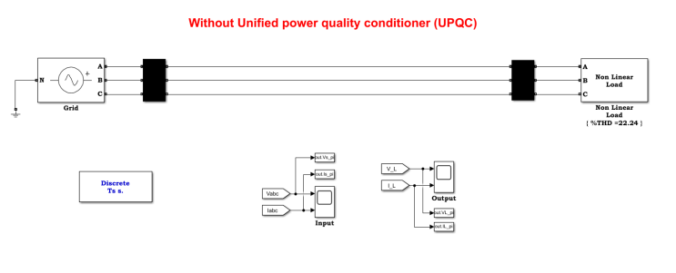

This system under consideration is shown in fig. 1.

The 3-phase system source is connected to non-linear load/

Voltage swell, sag and harmonic distortion are added to the system. In fig. 2 we can see the source voltage and current waveforms.

The output waveform of the load shown in fig. 3 still have some Voltage swell and harmonic distortion. The THD value as shown is 22.24%, Therefore we use UPQC to improve the power quality

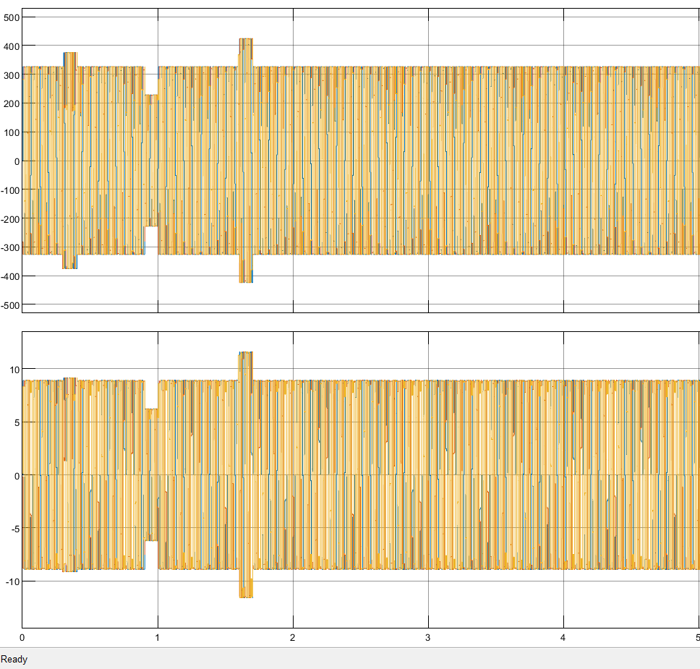

Fig. 2 (INPUT)

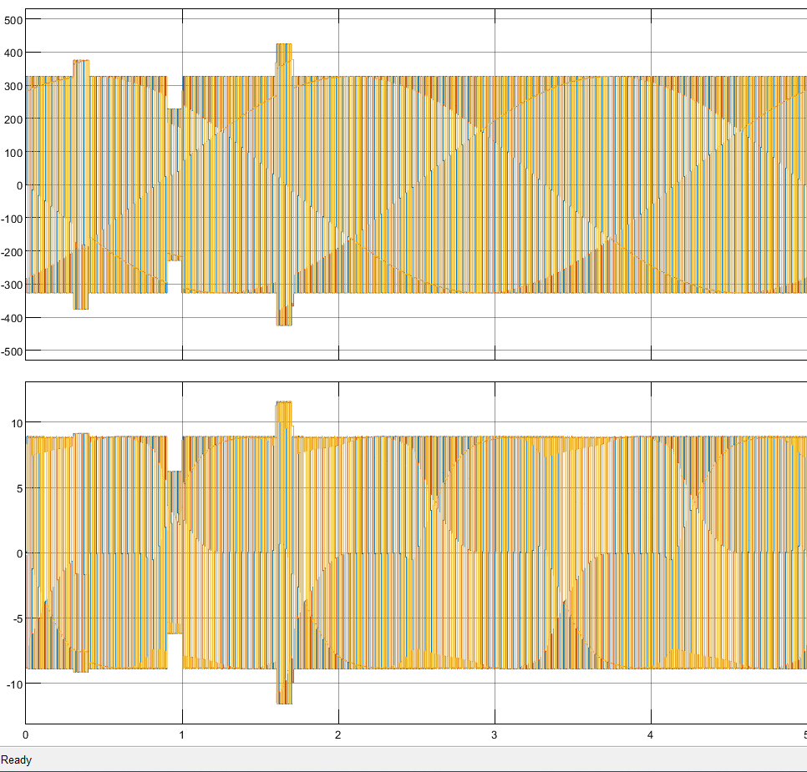

Fig. 3 (OUTPUT)

1. System description with UPQC:

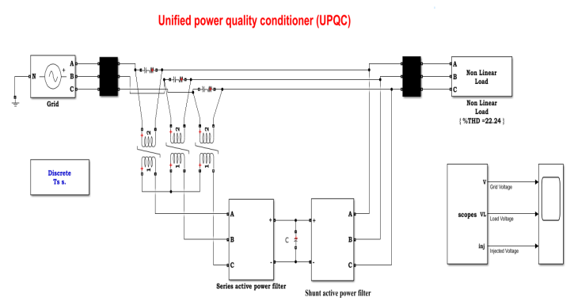

The system under consideration is shown in Fig.1.The UPQC is connected before the load to protect the load from any voltage based distortions and at the same time, to make the source currents sinusoidal, balanced and in phase with the source voltages. Provisions are made to realize voltage harmonics, voltage sag and swell in source voltage by switching on/off the three-phase rectifier load, R-L load and R-C load, respectively. In order to create a voltage dip in source voltage an induction motor is connected suddenly on the load side. The UPQC is realized by using two voltage source inverters (VSIs) connected back to back with a common DC link voltage, is shown in Fig.2. One VSI acting as a shunt APF, while the other as series APF. Each APF is realized by using six Insulated Gate Bipolar Transistors (IGBT) switches. The (isa, isb , isc) ,(ila, ilb , ilc) and (ifa, ifb , ifc,),represent the source currents, load currents and shunt APF currents in phase a, b and c respectively.

1. Control Strategy of UPQC:

Control strategy plays the most significant role in any power Electronics based system. It is the control strategy which decides the behaviour and desired operation of a particular system. The effectiveness of a UPQC system solely depends upon its control algorithm. The UPQC control strategy determines the reference signals (current and voltage) and, thus, decides the switching instants of inverter switches, such that the desired performance can be achieved.

# There are several control strategies/technique applied to UPQC system.

P-Q-R INSTANTANEOUS POWER THEORY

This method provides an analysis and control algorithm for a three phase four- wire Unified Power Quality Conditioner (UPQC) based on p-q-r instantaneous power theory. The p-q-r theory transforms a three phase four-wire voltage space vector into a single dc voltage and the corresponding currents into a dc based active power p- axis component and two imaginary power components, q- axis and r-axis.

SWITCHING CONTROL METHOD

In this method six single phase H -bridge inverters are used in the structure of UPQC connected to a common dc storage capacitor. Of these six inverters three of them are used for series voltage insertion and the other three are used for shunt current injection. The UPQC current and voltage references are generated based on Fourier series extraction of fundamental sequence components using half cycle running (moving) averaging.

1. Active Series Power Filter

They are connected in series with point of common coupling through saturation transformer.They are used to reduce sag and swell in the waveform by injecting voltage.

Inside the series filter controller reference voltage is generated which is compared with the load voltage(without UPQC) error and then is processed by hysteresis controller to generate a pulse.This pulse is used by the voltage source inverter to improve the voltage source at the load side.

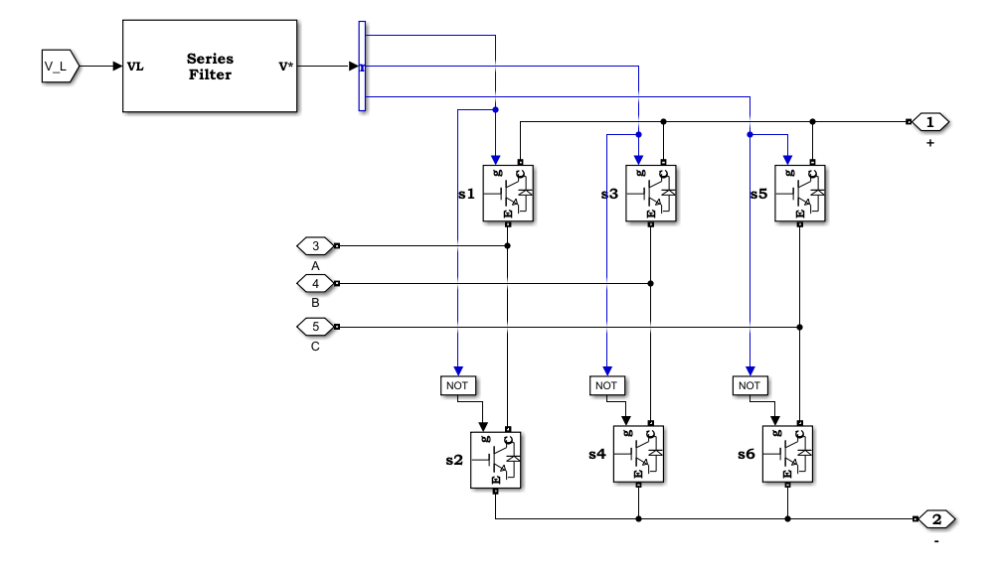

2Active Shunt Power Filter

They are connected in parallel and help in reducing harmonic distortion, also compensates the reactive power in the system.

Inside the controlling part of the shunt active power filer voltage across the DC link is measured which is compared with reference voltage(here 700) and then processed by the PI controller to give control signal Ploss.

Next compensating current is generated from three inputs i.e, Ploss, Load current IL and Source voltage Vabc using p-q strategy.

The compensating current acts as the reference current which is compared with actual current inside the Hysteresis Controller to generate the gating pulse.

This pulse is used by the inverter to improve the current and also to compensate the reactive power.

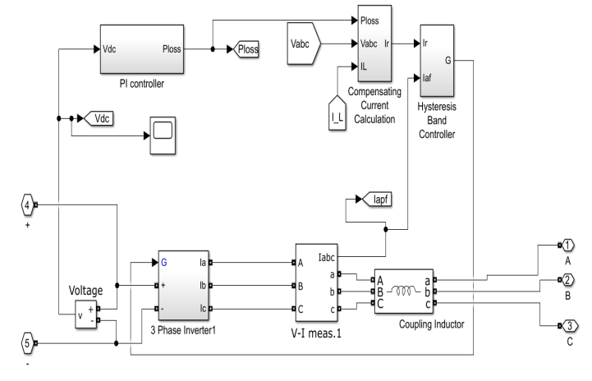

E) Conclusion:

The voltage mitigations and harmonic distortions were considerably removed using unified power quality controller. The THD value was reduced from 22.24 % to 2.45 %

The fig. 4 shows that the voltage swells and sags were removed from the output wave form and the distortion in the load current were compensated and we got pure sinusoidal waveform

Hence in UPQC using power filter, We could improve the power quality and get unified output waveforms for the non-linear loads

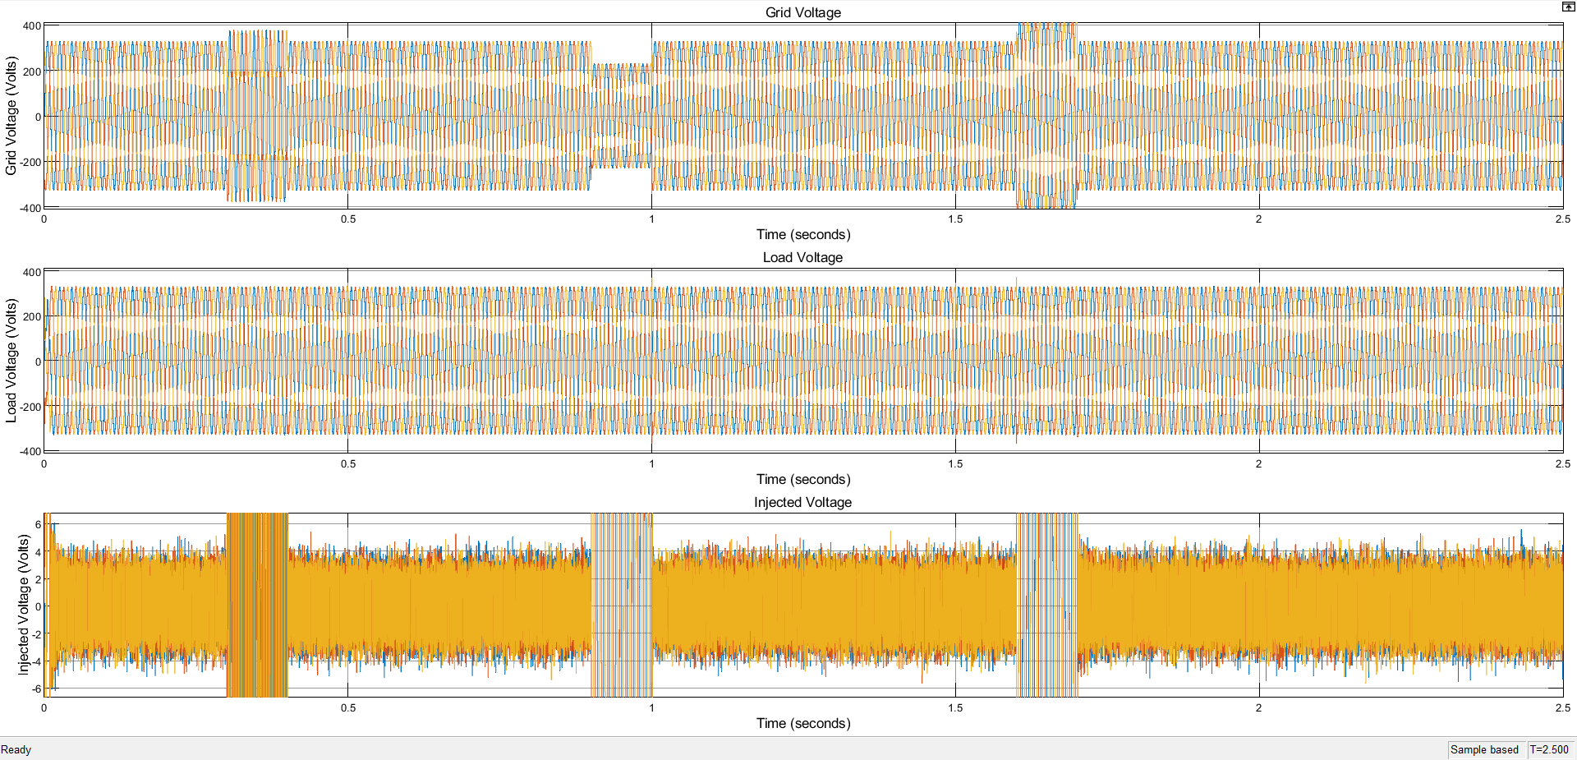

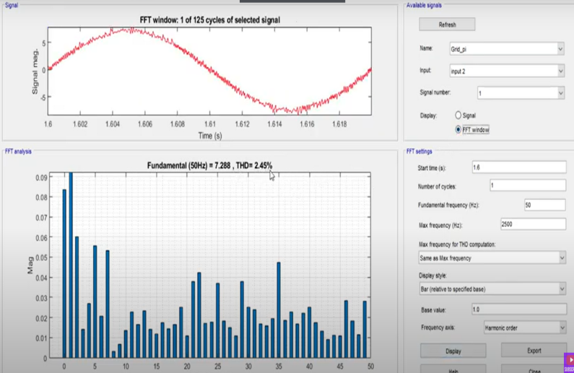

1. APPENDIX:

##### The system parameters used are as follows:

#### Supply voltage and line impedance: 400 V L-L, F=50 Hz,

#### non linear loads parameters: Load branch Rs=0.4, Load branch Ls= 15e-3 and load series Rs=60 and load series Ls=0.15e-3.

#### Active Filter: internal resistance Ron=1e-3Ω, Snubber resistance Rs=5µF, Snubber capacitance: CS=inf

#### Non Linear Loads: Load branch Rs=0.4, Load branch Ls= 15e-3 and Three-Phase Rectifier Load R=60 Ω and , Ls=0.5e-3 H. .

##### G) References:

1. B. Singh, AL.K. Haddad and A. Chandra, “A review of active filters for power quality improvement,” IEEE Trans. on Ind. Electron, vol.46, pp. 960– 971, 1999.
2. Yash Pal , A. Swarup , and Bhim Singh, *“*Performance of UPQC for Power Quality Improvement,” IEEE
3. Aakash S. Shah , Professor Vishnu Patel , Professor Manish Patel, “Different Control Strategies for Unified Power Quality Conditioner”, INTERNATIONAL JOURNAL OF INNOVATIVE RESEARCH IN ELECTRICAL, ELECTRONICS, INSTRUMENTATION AND CONTROL ENGINEERING Vol. 2, Issue 3, March 2014